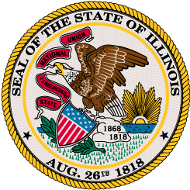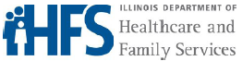

Prescriptions Reimbursed Below Cost Research Request Form

This form is to be completed by the pharmacy and emailed along with a copy of the invoice and claim information directly to Optum/Change Healthcare (smacdisputes@optum.com). We will research the “underpaid” claim and correspond back to the pharmacy all findings upon completion of research. All disputes must be submitted within 60 days of the date of service.
________________________________________________________________________

NPI #: ________________________________________________

Pharmacy Name: ________________________________________________

Contact Name: ________________________________________________

Pharmacy Phone #: ________________________________________________

Pharmacy Fax #: ________________________________________________

Drug Name: ________________________________________________

NDC #: ________________________________________________

Please include:
- Copy of recent Invoice for the claim in question. (All invoice information must be seen)
- Copy of the Claim initiating the inquiry for reimbursement review. (Claim must show RX#, NDC#, DOS and Amt paid).

Thank you,
Illinois SMAC Helpdesk
1-800-543-1288 voice

Web site: http://www.illinoissmac.com

